Time line

In the beginning of the project, an expected time line was generated and presented. Now after finishing the project, it is possible to compare the expected and actual needed amount of time for each subsection of the project (see figure \ref{fig: timeline}).

For most of the subsections, such as the project selection, team building, software architecture, generation of test data, optimization of the algorithm, protocol writing and the generation of the endpresentation, the expected amount of time is similar to the actual amount of time. Those subsections are mostly not dependend upon other previous tasks.

For the implementation of the algorithm however, four more weeks were necessary. Many of the images were hard to work with since the background is often very noisy and sometimes with dirt or undefined particles. Due to the fact that we did not have a limitless amount of images, we were dedicated to try to make the algorithm a very robust one. As visible in fig. X, the filtering, denoising and thresholding of the images was very time consuming even though now very successful. For the next steps of the algorithm, a robust binary image was necessary which is why it took much longer than expected.

The evaluation of the algorithms, test data and the biological results could only be performed after the successful establishing of the algorithm. Because of the delay in algorithm implementation, the evaluation took place as well four weeks later than expected.

In general, figure X shows that with the number of team members, effective, simultaneous working was possible during the project.

\begin{figure}[htb]

\begin{center}

**\includegraphics**[width = 0.7\textwidth]{041.png}

\end{center}

\caption{My Figure Caption.}

**\label{fig: timeline}** % you need to include this to reference the figure afterwards

\end{figure}

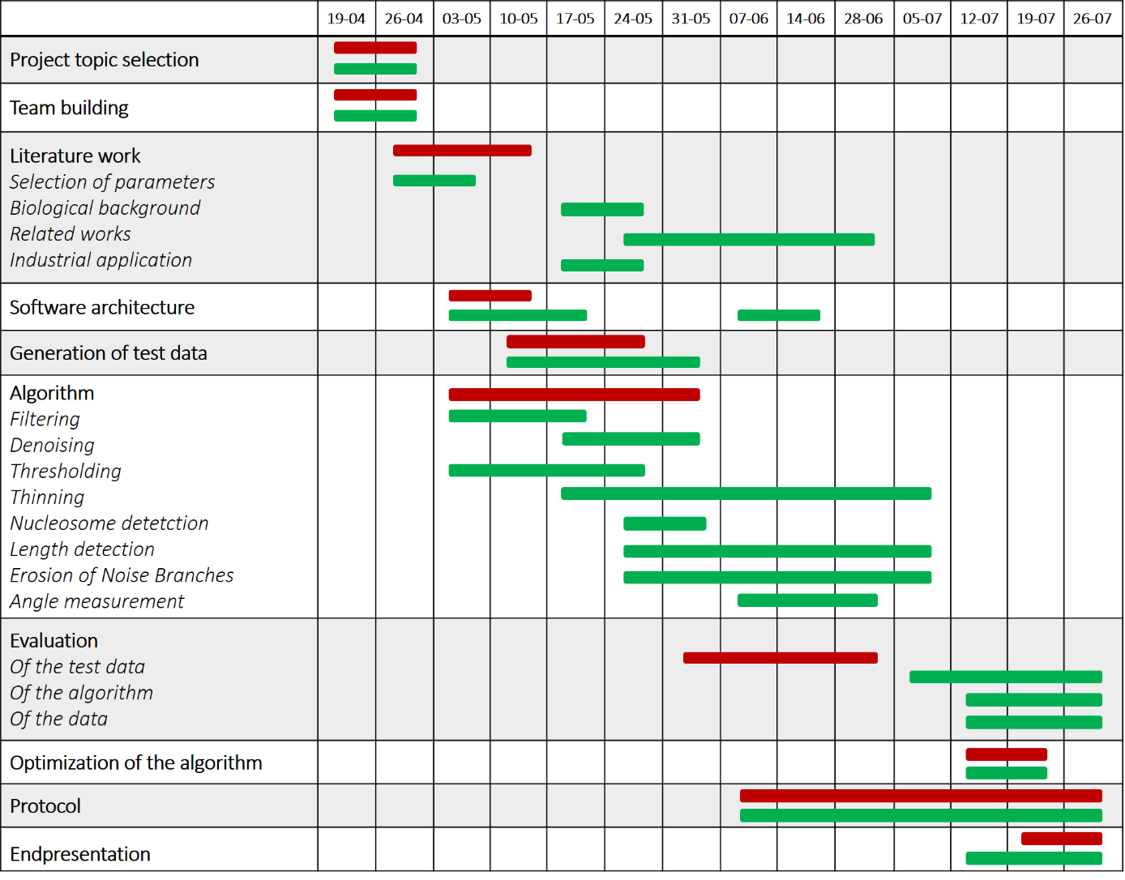

**Figure X: Project timeline.** For each subsection of the project, the expected needed amount of time is shown in red, the actual needed amount of time in green. The project was divided into the following subsections: Project topic selection, team building, literature work, software architecture, generation of test data, implementation of the algorithm, evaluation, optimization of the algorithm, writing of the protocol and creation of the endpresentation.